Soprano pipistrelle Pipistrellus pygmaeus

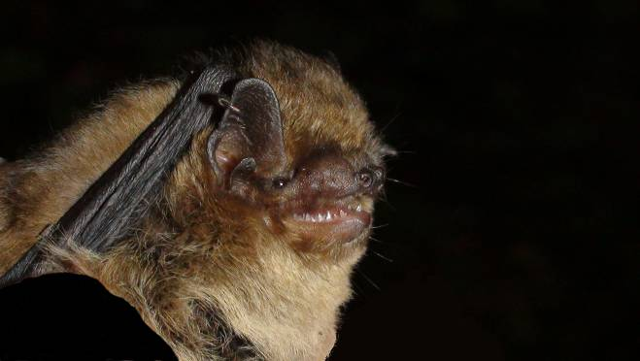
Background
Photo Martin Celluch © Bat Conservation Trust
Pipistrelles are the commonest and most widespread of all British bat species. There are two very similar species, common pipistrelle and soprano pipistrelle.

Soprano pipistrelles usually feed in wetland habitats, for example over lakes and rivers, and also around woodland edge, tree lines or hedgerows, and in suburban gardens and parks feeding mainly on small flies, particularly midges and mosquitoes that are associated with water.

Summer roosts of both common and soprano pipistrelles are usually found in crevices around the outside of often newer buildings, such as behind hanging tiles, soffit and barge or eaves boarding, between roofing felt and roof tiles or in cavity walls with colonies averaging 200 bats, but they can be even larger with numbers reaching several hundred to over a thousand bats. In winter soprano pipistrelles are found singly or in small numbers in crevices of buildings and trees, and also in bat boxes. They are often found in relatively exposed locations and rarely underground.

Status in Wales
Range | Widespread across Wales
Population | estimated numbers  63,000 in Wales (http://www.jncc.gov.uk/_speciespages/519.pdf)  763,400 in UK (http://www.jncc.gov.uk/_speciespages/519.pdf)

Threats
(taken from http://www.jncc.gov.uk/pdf/Article17/FCS2007-S1309-Final.pdf)
- Agricultural pressures
Use of pesticides
Abandonment of pastoral systems
- Forestry practices including clearance of undergrowth
- Pollution and infilling of water bodies
- Infrastructure
- potential threats due to exclusions from domestic buildings and cavity wall insulation.

Status
Wildlife & Countryside Act 1981(as amended), Schedule 5
The Conservation of Habitats and Species Regulations 2010, Schedule II
Natural Environment and Rural Communities Act 2006, s42
EC Habitats & Species Directive, Annex IV
Bern Convention, Appendix 2
Bonn Convention, Appendix 2

BAP
UK Biodiversity Action Plan
Species of principal importance for the conservation of biological diversity in Wales

Lead Partner – Bat Conservation Trust (www.bats.org.uk)

Wales BAP targets
Set in 2005 at UK level and adopted as Welsh target in 2009.
Targets to be reviewed in 2011
The target is to maintain the population of soprano pipistrelle in the UK and to increase the population from the base line by 2020. This is considered to be the case when the population index calculated from NBMP field surveys is maintained above 100 (i.e. there is no decrease in the population index indicative of a decline in actual population).

Code | Target type | Target | Units | 2005* | 2010 | 2015 | 2020 | 2025
PpyT1 | Population size | 1. Maintain soprano pipistrelle population above 2005 baseline level. | Population index | 100 | 100 | 100 | 100 | 100
PpyT2 | Population size | 2. Increase soprano pipistrelle population index by 2020 (level to be determined). | Population index | 100 | 100 | 100 | 135 | 135
* baseline

Actions
The following actions do not include statutory obligations with respect to species legislation, and investigation and enforcement measures of potential wildlife offences.

As a European Protected Species under the Regulation 9(5) Conservation of Habitats and Species Regulations 2010, a competent authority, must have regard to the requirements of the Habitats Directive in exercising any of their functions, so far as they may be affected by the exercise of those functions. This means that where a EPS is/or likely to be affected, then it will need to take account of the provisions provided by the Regulations.

Actions

Code | Action Type | Action | Action Lead | Ecosystem Groups | Delivery Agents
Ppy A1 | Survey and Monitoring | Continue to develop and implement population monitoring within the National Bat Monitoring Programme. | BCT (Steve Lucas) |  | BCT  LBAPs  JNCC
PpyA2 | Research | Promote, support or undertake research on the potential impact of windfarms and microturbines on this species within the UK. | BCT (Steve Lucas) |  | BCT  NRW Defra
PpyA3 | Habitat creation / restoration | Encourage the creation and/or protection of riparian habitats close to important soprano pipistrelle roosts and encourage improvements in water quality, to increase insect abundance in their preferred foraging habitat. | NRW (Rob Strachan) | Freshwater  Wetlands | LBAPs  NRW WTW
PpyA4 | Policy and Legislation | No action currently needed
PpyA5 | Communication and Advisory | 1. Influence standards, regulation and practice in the built environment to ensure the supply of potential bat roosts does not diminish. Promote the creation of roosting opportunities within the built environment as part of initiatives to promote energy efficiency.  2. Continue to provide practical advice to property owners with roosts thereby raising awareness of bat issues and improving relationships with roost owners. | BCT (Steve Lucas) |  | LBAPs  BCT  NRW

Implementation issues
Encourage new roost owners to sign up for monitoring and promote NBMP through domestic roost visits and talks, train volunteers to survey esp in the urban environment. Many o/o are becoming reluctant to acknowledge their roosts for fear that will prevent them from carrying out activities that might otherwise be unlawful or that it will hinder the sale ability of their property.
Research on windfarm and microgeneration impacts. Although there is a general lack of funding for this type of research, a number of research projects are being undertaken at Stirling University, Exeter University and Bristol University to look into impacts of wind turbines on bats.
Protection of large roosts and associated habitats
Work with building and insulation industry to ensure provisions made for bats; Research mitigation techniques. There is a policy by Govt to fully insulate private homes to ensure that new builds are zero carbon. Both are likely to reduce future and existing roosting opportunities unless appropriate mitigation techniques can be found.

Ecosystems approach and enhancing species resilience
The key issues are
- Restoration and maintenance of feeding habitat quality. Soprano pipistrelles usually feed in wetland habitats, feeding mainly on small flies, particularly midges and mosquitoes that are associated with water. There are therefore links primarily with the wetlands ecosystem group, and the freshwater ecosystem group.
- Safeguarding of roost availability. Bats require a variety of roosts within a population area

LBAP areas where action is required (shaded yellow)

All LBAP areas

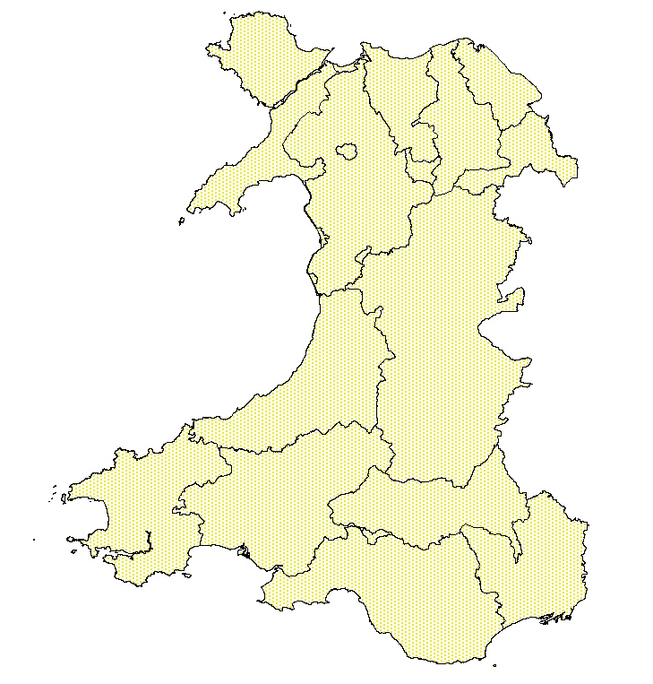

References/Links/Further Information
http://www.jncc.gov.uk/_speciespages/519.pdf
http://www.jncc.gov.uk/page-4063
http://www.ukbap.org.uk/
http://www.bio.bris.ac.uk/research/bats/britishbats/index.htm
http://www.bats.org.uk/publications_download.php/744/sopranopipistrelle.pdf

