Bechstein’s bat Myotis bechsteini

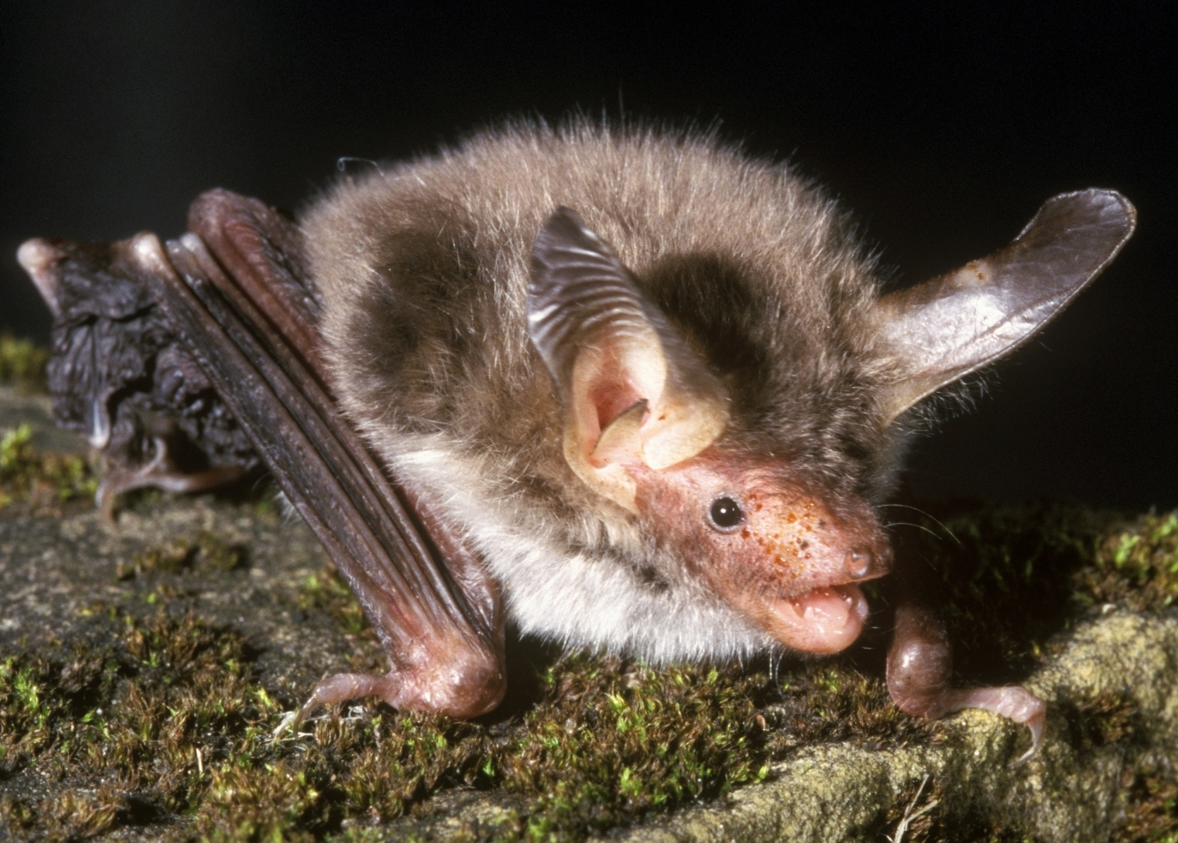
Background
Photo Hugh Clarke © Bat Conservation Trust
The Bechstein’s bat is one of the UK’s rarest bats, found almost exclusively in woodland habitat. Being one of the rarest mammals means we know relatively little about it.

Deciduous woodland provides most of the habitat for Bechstein’s bat - it uses woodland for roosting, foraging and almost certainly hibernation. Mature dense woodland is ideal, ensuring that Bechstein’s do not often come into contact with people.

In summer, they roost largely in woodpecker holes, although sometimes behind loose bark or in tree crevices (also occasionally in bat boxes). Maternity colonies are often spread across a number of roost sites, changing their location frequently throughout the summer. It is thought they hibernate in similar roosting sites to those it uses in summer, although perhaps in slightly deeper tree holes.

Bechstein’s bats tend to forage in woodland within a kilometre or two of their roost site and generally high up in the canopy although they are occasionally observed flying nearer the ground, They take prey from most insect groups.

Status in Wales
Range | To date, this bat has only been recorded from the Brecon area and from south Pembrokeshire
Population | estimated numbers  There are just two confined records from Wales  1500 in UK. (http://www.jncc.gov.uk/page-4063):

Threats
(taken from http://www.jncc.gov.uk/page-5170, 2007)
- Habitat loss/degradation:
Felling / loss of trees
Loss of hedgerows and scrub clearance
Inappropriate timing of forestry rotation
Agricultural enrichment
Pollution of freshwater
Infrastructure
- Human Disturbance:
Interference / displacement
Recreation and tourism
- Intrinsic - inbreeding

Status
Wildlife & Countryside Act 1981(as amended), Schedule 5
The Conservation of Habitats and Species Regulations 2010, Schedule II
Natural Environment and Rural Communities Act 2006, s42
EC Habitats & Species Directive, Annex II & IV
Bern Convention, Appendix 2
Bonn Convention, Appendix 2

BAP
UK Biodiversity Action Plan
Species of principal importance for the conservation of biological diversity in Wales

Lead Partner – Bat Conservation Trust (www.bats.org.uk)

Wales BAP targets
(set in 2009)
There is insufficient information to determine status or distribution in Wales. The target therefore is to gather such information so as to determine the range and distribution of Bechstein’s bat.

Code | Target type | Target | Units | 2005* | 2010 | 2015 | 2020 | 2025
MbT1 | Range | Establish a baseline distribution | Occupied 10 Km squares
* baseline

Actions
The following actions do not include statutory obligations with respect to species legislation, and investigation and enforcement measures of potential wildlife offences.

As a European Protected Species under the Regulation 9(5) Conservation of Habitats and Species Regulations 2010, a competent authority, must have regard to the requirements of the Habitats Directive in exercising any of their functions, so far as they may be affected by the exercise of those functions. This means that where a EPS is/or likely to be affected, then it will need to take account of the provisions provided by the Regulations.

Code | Action Type | Action | Action Lead | Ecosystem Groups | Delivery Agents
MbA1 | Survey and Monitoring | Encourage and support distribution surveys to locate populations and improve knowledge of distribution. | NRW (Jean Matthews) |  | BCT  VWT  LBAPs
MbA2 | Research | Promote, support or carry out research to improve knowledge of the relationship between habitat conditions and population performance. | NRW (Jean Matthews) |  | BCT  NRW  NRW
MbA3 | Habitat and Site Management | Ensure broadleaved woodland where the species occurs, or may occur, is managed to ensure the necessary features are maintained or improved in the long-term. | NRW (Chris Tucker) |  | NRW  NT/Woodland Trust  LBAPs
MBA4 | Habitat creation / restoration | No action currently identified
MbA5 | Policy and Legislation | No action currently needed
MbA6 | Communication and Advisory | Produce guidelines for Ecosystem Groups on appropriate habitat management for Bechstein's bats. Make this advice available to woodland managers. | BCT (Steve Lucas)

Implementation issues (and consideration of NEF principles)
- Ensure woodland habitat management for condition is appropriate to the needs of this species (continuous cover canopy and well developed under storey). This is vital to ensure this species has sufficient roosting and foraging habitat to sustain and preferably expand its populations. (This could also benefit other bat species e.g. Barbastelle).
- Encourage woodland expansion to help buffer core woodland areas and reconnection of fragmented woodlands to re-colonise previously occupied areas and to disperse and make seasonal movements for mating and hibernation. . Increase flight-line connectivity of woodland areas to each other and to other foraging habitats at the landscape level (e.g. via hedgerow creation). This would help multiple species with dispersion, adaptation (not just bats).
- Seek funding to re-start targeted surveys in Wales

AP areas where action is required (shaded yellow)

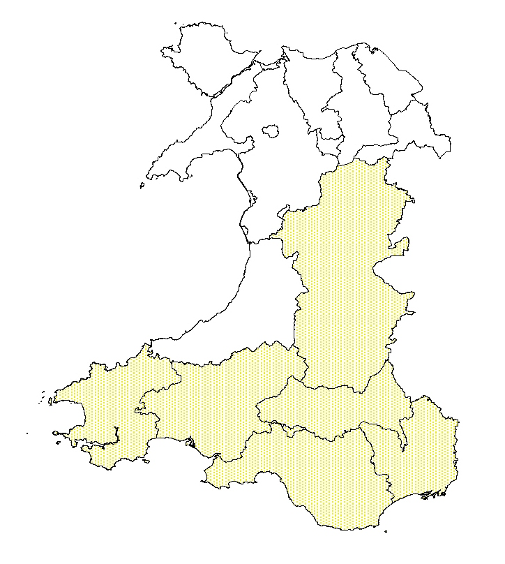

References/Links/Further Information
http://www.jncc.gov.uk/_speciespages/465.pdf
http://www.jncc.gov.uk/page-4063
http://www.bats.org.uk/publications_download.php/748/bechsteins.pdf

