Brown long-eared bat Plecotus auritus

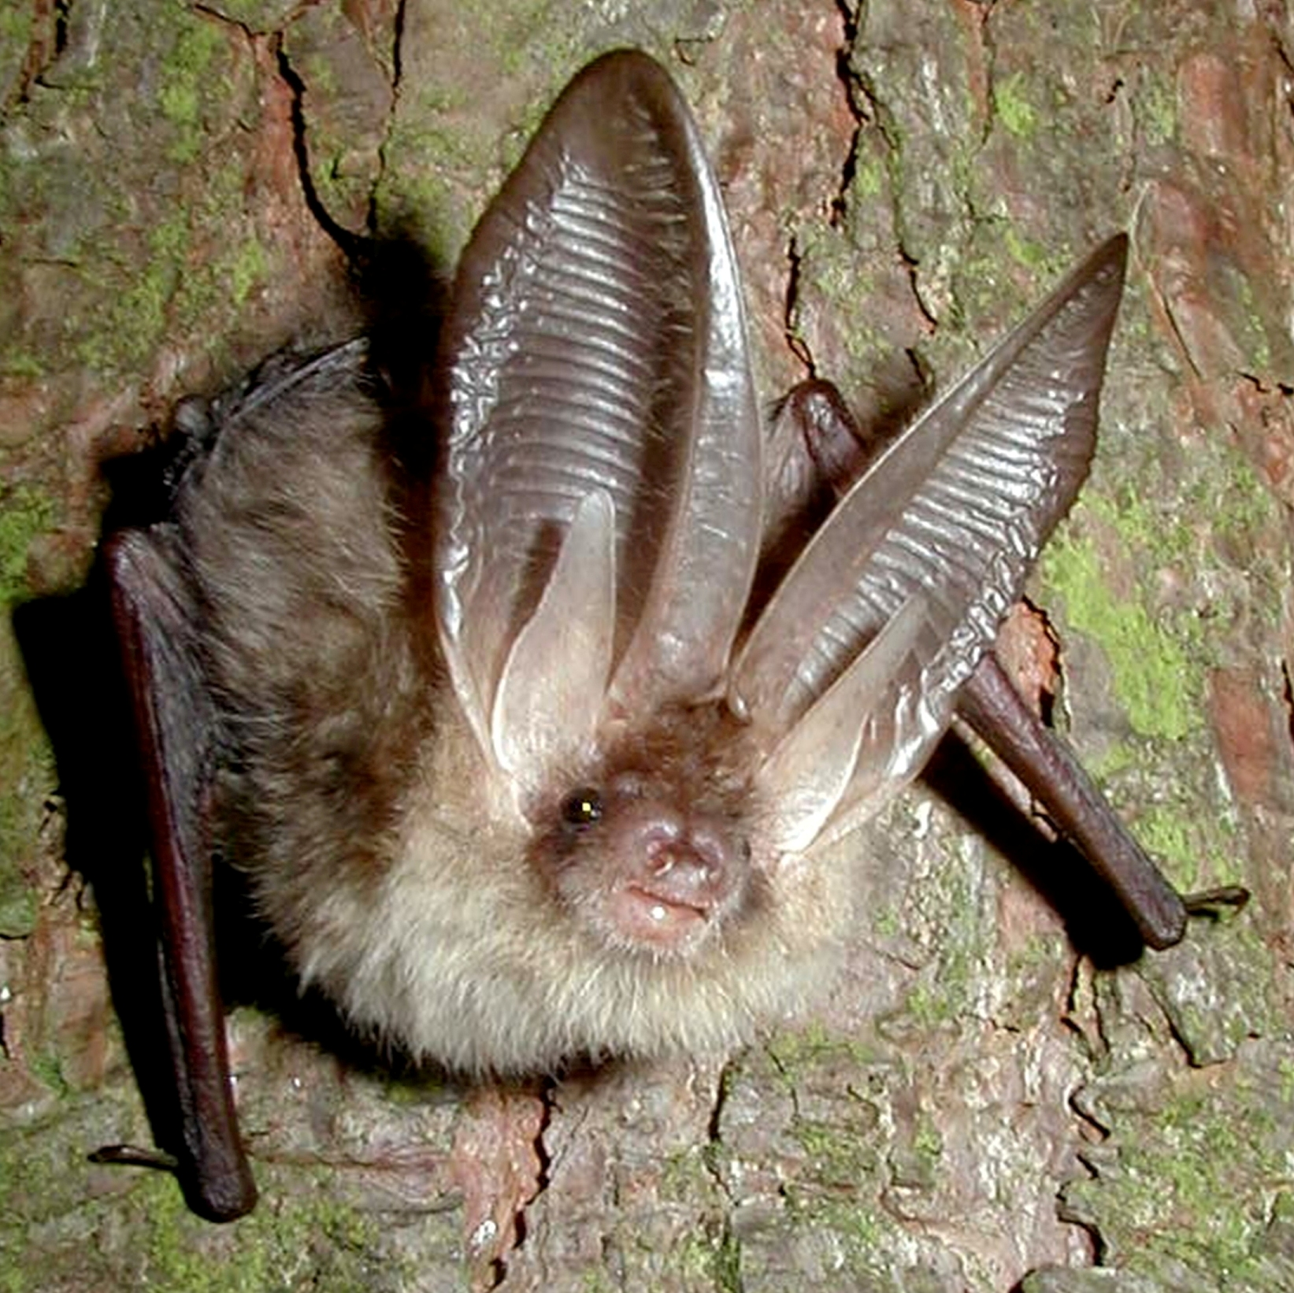
Background
Photo John Altringham © Bat Conservation Trust
In the summer, this highly characteristic bat can be found in older buildings, barns, churches where they have an uncluttered and large roost space in which to fly before they emerge although they do occur in trees and more enclosed roosts.

Colony sizes can vary considerably from just a few bats to several tens of bats. Winter roosts tend to be found in caves, tunnels, mines, icehouses and occasionally even trees and buildings.

Their foraging habitat is open deciduous and coniferous woodland, parkland and orchards where they feed on moths, beetles, flies, earwigs and spiders. Small prey is eaten in flight, but larger insects are taken to a ‘perch’, which are frequently inside porches or barns.

Status in Wales
Range | Insufficient information to determine status or distribution in Wales but it is probably widespread in low numbers across lowland Wales. It does occur in uplands during hibernation period
Population | estimated numbers:  c 17,500 in Wales (http://www.jncc.gov.uk/_speciespages/2517.pdf)  245,000 in UK (http://www.jncc.gov.uk/_speciespages/2517.pdf)

Threats
(taken from http://www.jncc.gov.uk/pdf/Article17/FCS2007-S1309-Final.pdf)
- Agricultural pressures
Use of pesticides
Abandonment of pastoral systems
- Forestry practices including clearance of undergrowth
- Removal of hedgerows and copses
- Pollution and infilling of water bodies
- Infrastructure

Status
Wildlife & Countryside Act 1981(as amended), Schedule 5
The Conservation of Habitats and Species Regulations 2010, Schedule II
Natural Environment and Rural Communities Act 2006, s42
EC Habitats & Species Directive, Annex IV
Bern Convention, Appendix 2
Bonn Convention, Appendix 2

BAP
UK Biodiversity Action Plan
Species of principal importance for the conservation of biological diversity in Wales

Lead Partner – Bat Conservation Trust (www.bats.org.uk)

Wales BAP targets
(set in 2009)
The aim is to maintain the range in Wales and to increase the population index. Once we have better understanding of the numbers the population index then we will be able to set specific targets.

Code | Target type | Target | Units | 2005* | 2010 | 2015 | 2020 | 2025
PaT1 | Range | 1. Maintain Brown long-eared range in Wales | Occupied 10 Km squares
PaT2 | Population size | 2. Increase brown long-eared population index. | Population index
* baseline

Actions
The following actions do not include statutory obligations with respect to species legislation, and investigation and enforcement measures of potential wildlife offences.

As a European Protected Species under the Regulation 9(5) Conservation of Habitats and Species Regulations 2010, a competent authority, must have regard to the requirements of the Habitats Directive in exercising any of their functions, so far as they may be affected by the exercise of those functions. This means that where a EPS is/or likely to be affected, then it will need to take account of the provisions provided by the Regulations.

Code | Action Type | Action | Action Lead | Ecosystem Groups | Delivery Agents
PaA1 | Survey and Monitoring | Continue to develop and implement population monitoring within the National Bat Monitoring Programme. | BCT (Steve Lucas) |  | BCT  LBAPs  JNCC
PaA2 | Research | Undertake research on the impact of light pollution on the brown long-eared bat as well as the finer habitat requirements of the species, to enable provision of more effective advice to the relevant Ecosystem Groups and subsequent appropriate habitat delivery. | BCT (Steve Lucas) | Woodland  Lowland farmland | BCT  NRW
PaA3 | Habitat creation / restoration | Encourage the retention, planting and expansion of woodland, parkland and amenity trees and hedgerows within the vicinity of significant brown long-eared roosts. Promote best practice to ensure that the roosts are protected from avoidable loss (e.g. felling) | NRW (Chris Tucker)) |  | LBAPs  Woodland Trust  NRW
PaA4 | Habitat creation / restoration | No action currently identified
PaA4 | Policy and Legislation | No action currently needed
PaA5 | Communication and Advisory | 1. Influence standards, regulation and practice in the built environment to ensure the supply of potential bat roosts does not diminish. Promote the creation of roosting opportunities within the built environment as part of initiatives to promote energy efficiency.  2. Continue to provide practical advice to property owners with roosts thereby raising awareness of bat issues and improving relationships with roost owners. | BCT (Steve Lucas) |  | LBAPs  BCT  NRW

Implementation issues (and consideration of NEF principles)
- Work with building and insulation industry to ensure provisions made for bats
- Encourage new roost owners to sign up for monitoring and promote NBMP through domestic roost visits and talks, train volunteers to survey
- Targeted surveys of old churches and other potential roosts
- Tighter mitigation and planning
- Research mitigation techniques esp those relating to re-roofing

Priority LBAP areas where action is required (shaded yellow)
Targeted surveys to determine population index – all LBAP areas

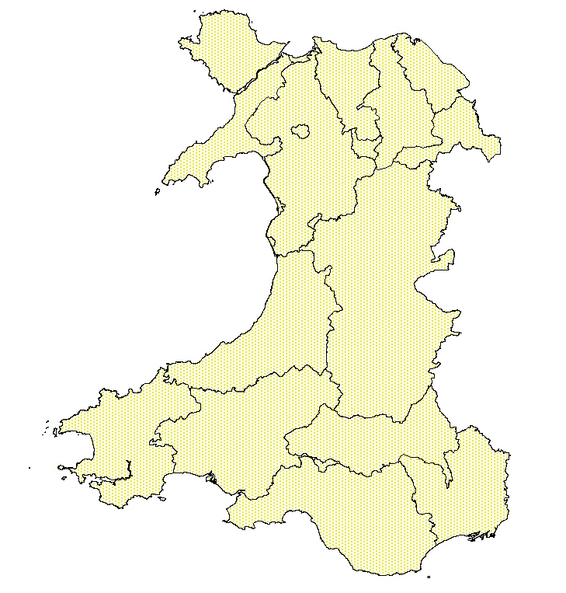

References/Links/Further Information
http://www.jncc.gov.uk/_speciespages/2517.pdf
http://www.jncc.gov.uk/page-4063
http://www.ukbap.org.uk/
http://www.bats.org.uk/publications_download.php/213/brownlongeared.pdf

